DelMarVa NAVHDA will be hosting a NAVHDA Aims and Rules Clinic on June 6 & 7, 2026 at

The C&R Center. This is a two-day training so you must be able to attend both days. The cost is

$125.00 per person. Entries must be received no later than May 30, 2026.

This is a RAIN OR SHINE event. If you need to cancel, you must cancel prior to May 15,

2026. After this date, if the club is still able to fill the entry/entries, the refund will be 80% of

the entry fee. If the Club is unable to fill the entry/entries, No Refund will be given.*

*In the event that special or extenuating circumstances impact the timely cancellation of an

entry, an entrant may submit an appeal letter to the Executive Council of DelMarVa

NAVHDA requesting a refund. For additional information on the refund appeal

Process, please contact the Chapter President.
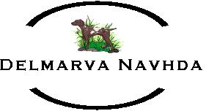

NAME: ______________________________________________________________________
MAILING ADDRESS: __________________________________________________________
______________________________________________________________________________
PHONE NUMBER: _____________________________________________________________
E-MAIL ADRESS: _____________________________________________________________
AMOUNT ENCLOSED: ________________

